SMARTBRIDGE EXTERNSHIP PROGRAM

DATA ANALYTICS

ASSIGNMENT 3

ASSIGNMENT CREATED BY: ROHIT YADAV

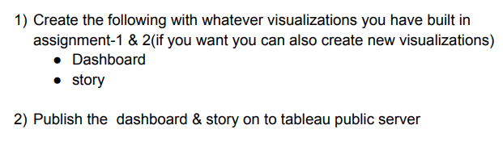

**Dashboard:**

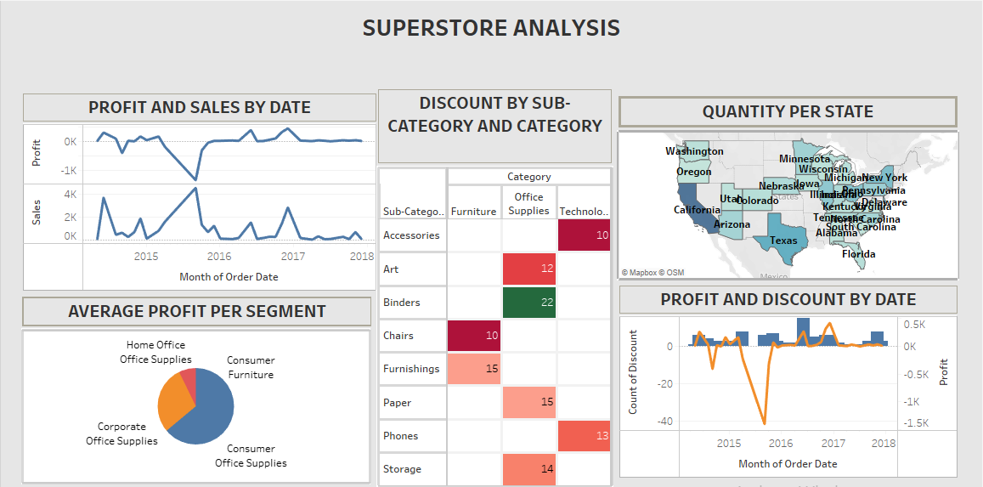

Tableau Public Published Link: <https://public.tableau.com/views/assignment_workbook/Dashboard1?:language=en-US&publish=yes&:display_count=n&:origin=viz_share_link>

**Story:**

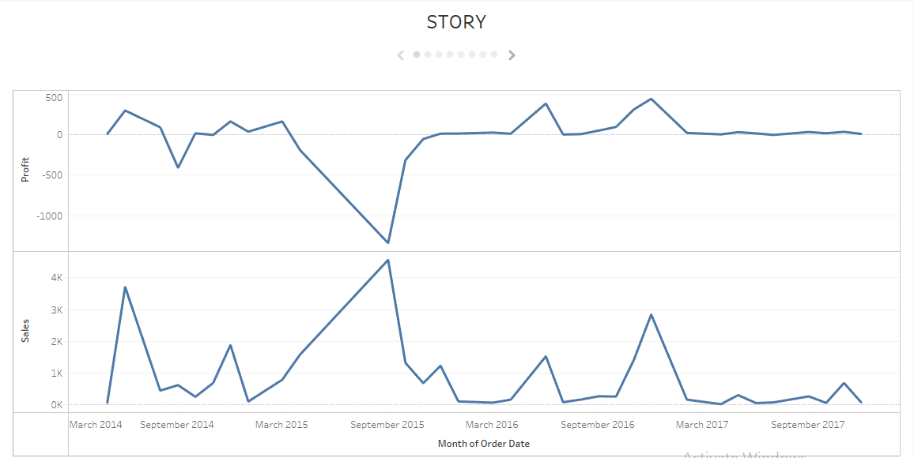

Tableau Public Published Link:

<https://public.tableau.com/views/assignment_story/Story1?:language=en-US&:display_count=n&:origin=viz_share_link>